The Good, The Bad, The Perfect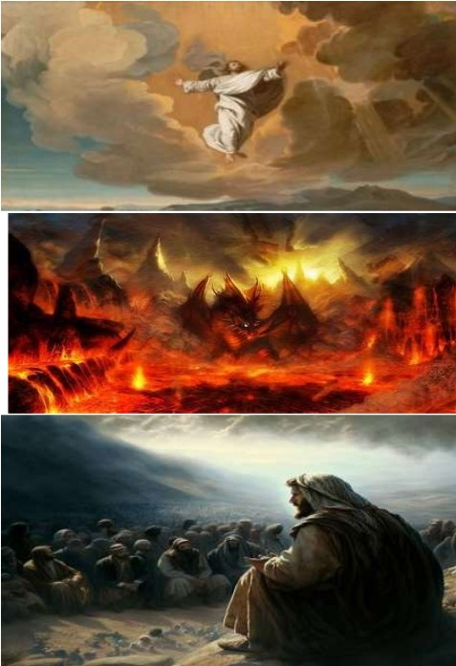Roberto Santiago
The Good - God's Creation and His Plan
In the beginning, there was only God. He existed before time, before space, before everything we know. From His divine creativity, He created the universe and everything within it. Genesis 1:31 says, "God saw all that he had made, and it was good.” This declaration encompasses the goodness of God's creation. From the magnificence of the galaxies to the intricacy of every living being, God's handiwork was perfect, harmonious, and beautiful.
God's goodness is further revealed in His loving intention for humanity. He created Adam and
Eve in His image of love, mercy, peace, just, faithfulness and ability to reason and decide. He placed them in the Garden of Eden, where they enjoyed a perfect
relationship with Him. Genesis 1:27 affirms this: "So God created mankind in his own image, in the image of God he created them; male and female he created them." God's goodness was not only in His creation but also in His plan for humanity to live in harmony with Him and each other.

The Bad - The Deceiver, Accuser, and Destroyer
The story takes a tragic turn with the introduction of evil. Satan, once an angel of light, fell from grace due to pride and became the embodiment of deception and destruction. In Revelation 12:9, he is described as "that ancient serpent called the devil, or Satan, who leads the whole world astray." Satan's mission is to accuse, deceive, and destroy God's creation. He is relentless in his attempts to lead humanity away from God and into sin.
Satan's destructive influence is evident in the disobedience of Adam and Eve. When they succumbed to his deceit and ate from the forbidden tree, sin entered the world, and the perfect harmony of God's creation was shattered. Romans 5:12 laments this, stating, "Therefore, just as sin entered the world through one man, and death through sin, and in this way death came to all people because all sinned."

The Perfect - Jesus, the Redeemer and Restorer
In the midst of chaos and despair, God had a plan for redemption. He sent His own Son, Jesus Christ, as the perfect solution to reconcile humanity to Himself. Jesus, fully God and fully man, came into the world to destroy the works of the devil (1 John 3:8). His birth, known as
Emmanuel, signaled God's presence among us, bringing hope of restoration to a fallen world. Jesus' perfect life, sacrificial death on the cross, and triumphant resurrection offer salvation and restoration to all who believe in Him

and followed His command to be baptized. Baptism is the calling on God for forgiveness by one having died to their old sinful life. It is a burial by immersion in the Christ’s atoning sacrifice blood. Like Jesus was resurrected, God resurrects the one pleading for forgiveness from the waters of baptism to become a new creation in Christ Kingdom. (Romans 6:4). Through faith in Christ, we are made perfect in God's sight, not by our own merit. Still, by His grace (Hebrews 10:14). Jesus came to undo the consequences of sin, offering eternal life. and a new beginning to those who embrace Him becoming His servant in His Kingdom.

The concept of restoration is beautifully depicted in Revelation 21:5, "He who was seated on the throne said, 'I am making everything new!'" God's plan has always been to redeem His creation and restore it to perfection. Those who accept Jesus as their Savior will dwell with Him in a new heaven and a new earth, where there will be no more pain, suffering, or sin (Revelation 21:1-4). The story of God's creation, the fall into sin, and the redemption through Jesus is a powerful narrative of God's goodness, the devastating impact of evil, and the perfect work of salvation. As believers, we are called to be "perfect as your heavenly Father is perfect" (Matthew 5:48) and to live according to God's original design, restored through faith in Christ. It is through Jesus that we find hope for forgiveness, and the promise of a new world where God's goodness will once again reign supreme.

