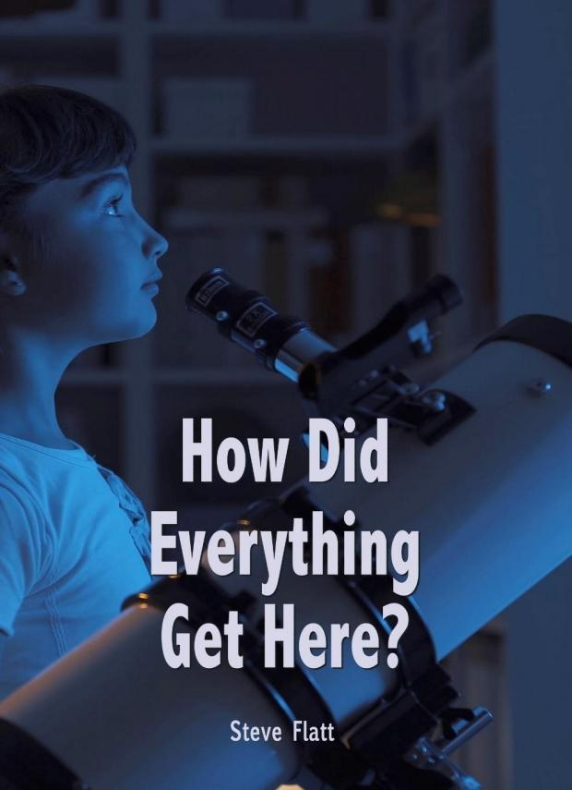

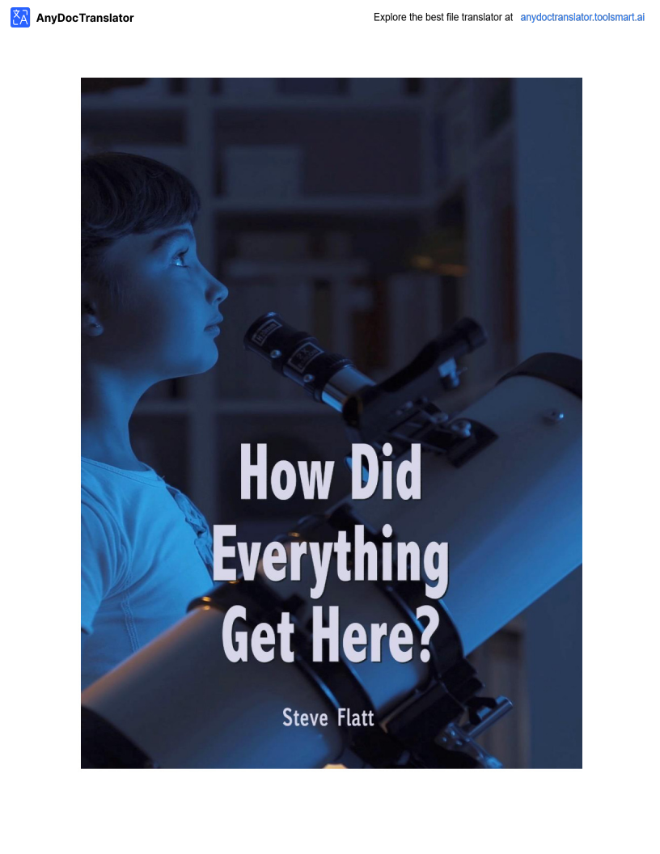

How Did Everything Get Here?
Creation or A Big Bang?
How did everything begin? Where did everything come from? The first things a human being becomes aware of are things around him, the external world. When a baby comes into this world, he or she is more aware of people and things than he is about himself. It's more of an awareness of the externals than of the internals. As time goes on, they begin to realize that there are questions about where all these things came from. A relatively young child might begin asking questions about origin and those questions are simple at first. A child may say, "Where did the stars in the sky come from?" A simple question usually gets a simple answer. If the parent is a believer in God, a Christian, the answer might be, "God put them there." If the parent is an atheist, anon-believer, the answer might be, "along time ago there was just a huge explosion and things just landed in space."

As they grow older the questions become more sophisticated, not just “how did the stars get there” or “how did the moon get there”. How do we explain galaxies that are trillions of lightyears away? How do we explain the complexity of the human body, the human brain, the kidney, or the eye? How do we explain all of the laws and properties of physics that hold all these things together? Where did all that come from? More sophisticated questions demand more sophisticated and reasonable answers. We want logically formulated answers that will withstand questioning and probing. It's also right that we should ask about the origin, and demand an answer that is accurate with all known data and sensible in the face of questioning by us and by critics. It is an insult to our intelligence to accept an answer that is untrue or that is poorly formulated.

We begin to see that the source of everything that is, is a source that's supernatural, a source that is of supreme power and intellect and a source that has amorality and an ethic. By definition that source is named God. Here's what Paul said in Romans 1:20, "For since the creation of the world, God's invisible qualities, His eternal power and divine nature have been clearly seen, being understood from what has been made so that men are without excuse." Paul was right. If you can't look around and see what has been made and realize that the tremendous amount of evidence there for that supernatural, all-powerful, all-intelligent, all-moral God, what could possibly prove it to you?

Where did everything come from? Everything came from the Almighty God of heaven and earth, who loved us and created us and everything we see.

Kedu ka ihe niile si abịa ebe a? Okike ma ọ bụ nnukwu akụ?
Olee otú ihe niile si malite? Ebee ka ihe niile sitere? Ihe mbụ mmadụ na-amata bụ ihe
gbaraya gburugburu, ụwa nke mpụga. Mgbe nwa batara n'ụwa a, ọ maara karịandị
mmadụ na ihe karịaya onwe ya. Ọ bụ ihe mmata nke ndị mpụga karịa nke indeciles. Ka oge na-aga n'ihu, ha na-amalite ịghọta na e nwere ajụjụ banyere ebe ihe ndị a niile si. Nwatakịrị nwa nwere ike ịmalite ịjụ ajụjụ banyere mmalite na ajụjụ ndị ahụ dị mfe na
mbụ . Nwatakịrị nwere ike ịsị, "Olee ebe kpakpandodị na mbara igwe si?" Ajụjụ dị mfe na-enweta azịzadị mfe. Ọ bụrụ na nne ma ọ bụ nna bụ onye kwere ekwe na Chineke,
Onye Kraịst, azịza ya nwere ike ịdị, "Chineke tinyere ha ebe ahụ ." Ọ bụrụ na nne ma ọ bụ nna ahụ bụ onye na-ekweghị na Nna ahụ, onye na-abụghị onye kwere ekwe, azịzaya nwere ike ịdị, "ogologo oge gara aga, e nwere nnukwu mgbawa na ihe ndị rutere na
mbara."

Ka ha na-etolite ajụjụ a na-enwekarị ọkaibe, ọ bụghị naanị "kpakpando ahụ ga-esi ruo
ebe ahụ" ma ọ bụ "Kedu ka ọnwa si ruo ebe ahụ". Kedụ ka anyị si kọwaa ụyọkọ
kpakpandondị bụbu afọ nke afọ ọkụ? Kedụ ka anyị si kọwaa ịdị mgbagwoju anya
mmadụ, ụbụrụ mmadụ, akụrụ, ma ọ bụ anya? Kedụ ka anyị si kọwaa iwu na
akụrụngwa niile nke na-ejikọ ihe ndị a niile? Ebee ka ihe niile si?Ajụjụ ndị na-atọ ụtọ chọrọ ka ọ bụrụ ezigboazịza. Anyị chọrọ azịza nke uche n'ụzọ nke uche ga-egbochi ajụjụ na ikeli. Ọ bụkwa eziokwu na anyị kwesịrị ịjụ banyere mmalite ahụ, ma jiriazịza nke ziri ezi na data niile amaara na ezi uche na ihu nke anyị na ndị nkatọ na-ajụ anyị ajụjụ . Ọ bụ mkparị nye ọgụgụ isi anyị ịnabata azịza nke abụghị eziokwu ma ọ bụ nke anaghị edoziya.

Anyị na-amalite ịhụ na isi iyi nke ihe ọ bụladị, bụ isi iyi nke ike, isi iyi nke ike na ikike kachasị elu na isi iyi nke omume na ụkpụrụ omume. Site na ịkọwapụta isi iyi ahụ aha Chineke. Nke a bụ ihe Pọl kwuru na Ndị Rom 1:20, "n'ihi na ihe mere ụmụ nwoke
na-adịghị ahụ anya, a hụrụla ike nke Chineke na-enweghị ihe ngọpụ ." Paul bụ
eziokwu. Ọ bụrụ na ịnweghị ike ịhụ ihe e mere ma chọpụta na nnukwu ihe akaebe na-egosi na ikike dị ukwuu maka ikike dị iche iche, oleekwa Chineke nwere ọgụgụ isi, gịnị nwere ike igosigị?

Ebee ka ihe niile sitere? Ihe nile sitere n'aka Chineke nke Pụrụ Ime Ihe Niile nke eluigwe na ụwa, ndị hụrụ anyị n'anya ma kee anyị ihe niile anyị na-ahụ .

Natural Law or Supernatural Force?
When asked the question about the origin, the Christian's insight is that this world had to have a supernatural beginning. The very beginning of the Bible, God's Word, says "In the beginning, God created the heavens and the earth." (Genesis 1) That same thing is verified over and over again in the scripture. "He wraps himself in light as with a garment, He stretches out the heavens like a tent and lays the beams of His upper chambers on their waters. He makes the clouds His chariot and He rides on the wings of the wind. He makes winds his messengers, flames of fire His servants. He set the earth on its foundation." (Psalm 104) Who created everything there is? God did - God the Father, Son and Holy Spirit.

Also, Colossians 1:16, states "For by Him all things were created, things in heaven and on earth, visible and invisible, whether thrones or powers or rulers or authorities, all things were created by Him and for Him. He is before all things and in Him, all things hold together." Those are the answers for the Christian. How did everything get here? There was a supernatural force.

But for those who would hold to the premise that everything came about through natural forces, they find themselves in a position that knows no defense.

There are two basic things in this universe. There is matter and there is energy. The problem is that neither matter nor energy have in and of themselves any creative force. Matter does not create other matter. A piece of wood does not naturally create another piece of wood. Matter and energy are continually being used up. How many times have you heard scientists tell us that this universe of ours is running down? We are told that our sun, which is a star in the Milky Way galaxy, is about middle age. Supposedly, a billion years from now our sun will eventually use all its energy. It's winding down. Ifour universe is composed of matter and energy, where did those things come from? By natural law, they did not create themselves. Where did they come from? By natural law, they are winding down and are going to be spent up. Who created the great storehouse of energy in the first place? Natural science knows no answer.

The current scientific theory holds that light, whenever it was created, came from non-living matter. That's an interesting assumption, isn't it? In a book published not that long ago called “Issues and Evolution”, it states that very thing, "The assumption that all life comes from nonliving matter must be made by the modern scientist if he believes that the question, 'What is life?' belongs in the natural sciences." The point is those who propose that there was no supernatural cause must propose that life came from something not alive. But, that flies in the face of modern science. Have you ever heard of the theory of spontaneous generation, a theory that was popular

Iwu eke ma Q b4 ikike kariri nke mmad4?
Mgbe a j4r4 aj4j4 banyere mmalite ah4 sitere na nghQtaOnye Kraist b4 na 4wa a
nwere mmalite kariri nke mmad4. Mmalite nke Bible, Okwu Chineke, kwuru "na
mbido, Chineke kere eluigwe na 4wa." (Jenesis 1) Otu ihe n'akw4kwQ NsQ ah4. Q
na-esetip4 onwe ya n'ìhè, Q na-ese n'elu 4lQikwuu di ka 4lQikwuu nke ikuku. Q na-eme ka ndi oziya di elu. O guzoro elu n'elu ebe ntQalaya. " (Ab4 Qma 104) Ole ndi kere ihe niile di? Chineke mere - Chineke b4 Nna, Qkpara,Qkpara na mm4Q nsQ.

QzQkwa, ndi KQlQsi 1:16, kwuru na e kere ihe niile "n'ihi na e kere ihe niile, nke di
n'eluigwe na 4wa, ma Q b4 n'ihuya na ya. Q na-emekQ ihe niile na ya." Aziza ndi ah4 b4 aziza nke Ndi Kraist. Kedu ka ihe niile si abia ebe a? Enwere ike kariri nke mmad4.

Mana maka ndi ga - ejide ya na ihe niile sitere na ndi agha sitere na ndi sitere na ndi sitere n'okike, ha na - ah4 onwe ha n'QnQd4 enweghiQnQd4 Q b4la amaghi.

E nwere ihe ab4Qdi iche iche na mbara igwe a. Enwere ike na enwere ike. Ihe b4 ihe kpataraya b4 na Q b4ghi ihe Q b4la ma Q b4 ikeya nwere na onwe ha ike okike. Di
mkpa anaghiekerita okwu ndi QzQ. Otu osisi anaghiemep4ta osisi QzQ. A na-eji okwu na ume di. Ugboro ole ka i n4r4 ka ndiQkà mm4ta sayensi na-agwa anyi na 4wa niile nke anyi na-agbada? A gwara anyi na anyanw4 anyi, nke b4 kpakpando n'ime 4yQkQ kpakpando Milky Way, b4 ihe di ka etiti. N'ezoghi Qn4, otu ijeri afQ sitere ugbu a
anyanw4 anyi ga-emesia jiri ikeya niile. Q na-eme mkpQt4. Q b4r4 na anyiji okwu na ume, ebee ka ihe ndiah4 si bia? Site n'iwu okike, ha ekeghi onwe ha. Ebee ka ha si bia? Site na iwu eke, ha na-agbada ma na-emefu ya. Onye kere nnukwu 4lQ nkwakQba nke ike na mb4?Qkachamara na sayensiamaghi.

Usoro mm4ta sayensiugbu a na-ejigide 讠hè, mgbe o kereya, sitere n'okwu ndi na-ab4ghindi bi. Nke ah4 b4 echiche na-atQ 4tQ, Q b4ghiya? N'ime akw4kwQ
ebip4taghi na nke ah4 ma e mep4ta na evolushQn ", Q na-ekwup4ta ihe sayensi Qh44 ga-eme ka Q b4r4 na Q kweere na aj4j4 a, 'Gini b4 nd4?' so na sayensi. " Isi ihe a
na-ekwu na Q nweghi ikike kariri nke mmad4 ga-enyekari na nd4 ah4 adighi nd4. Ma, nke ah4 na-efeghari n'anyasayensi Qgbara Qh4r4. Yourt4t4la banyere Ozizi nke QgbQ na-adighi mma, ak4kQ a ma ama

in the 19th century that life did indeed come from non-living matter? The ancients used to believe that worms actually came from horsehairs that were dipped in water. Ah, but along came a noted scientist by the name of Louis Pasteur. You may have heard of him, he was big in milk. Pasteur through a number of experiments verified the conclusion that life cannot come from nonliving matter. Do you see the point? Do you see that those who say that this world and this universe somehow just have always been?

Science has to repudiate itself to hold anon-creationist view. As we look at this question, "Where did everything come from?" When reduced to a choice, either there was a supernatural creative force, or there was just natural law. There's really no choice to be made. There had to be a supernatural force.

Is it hereby design or is it hereby accident?
Consider the fact that our world is filled with millions of living things, anyone of which is more complex and sophisticated than any man-made object. In other words, there must have been a great deal of intelligence associated with that supernatural force that put everything here. Our body is composed of literally hundreds of millions of cells. Did you know that each tiny cell has an electrical system that's more complex than the telephone system of a city of 30,000 people? Isn't that amazing? The question is, "Is there any man-made object that we would account for apart from intelligent design and production?" Imagine the telephone system in a city the size of New York City. Think about all the switches, all the intricate wiring, the satellite up-link. Think about all that went into that. Imagine somebody telling you that nobody designed that. Nobody drew any pictures, there weren't any plans, and nobody manufactured that entire scenario, but it just simply happened. The biggest fool in the world wouldn't believe that. Basic rationality says that if we see something that complex, we assume design and intelligence. Since it is ridiculous to think that any man-made device was made without design and production, how much more ludicrous is it to assume that there was no design in these non-man-made objects, any one of which is more complex? The human brain, the human body, the kidney - the greatest filtering system in the world. One scientist set forth in a recent journal that the chance of one protein molecule falling together in place at random - the chance of that was 1 x 2.02 x 10 raised to the 239th power. Is it by chance or was it design? The believer accepts passages like Psalm 19:1 when David wrote, "The heavens are declaring the glory of God and the firmament proclaims His handiwork." There was indeed a design and it was magnificent.

Supernatural or Natural?
It was supernatural. Design or accident? It had to have been design. But what about the nature of that Creator? I'm finding more and more people in our world are willing to accept the fact that

Na narị afọ nke 19 na ndụ ahụ sitere n'aka ndị na-abụghị ndị bi na ya? Ndị oge ochie ahụ kwenyere na ikpuru sitere na ntutu isi na-esite na mmiri na-etinye na mmiri. Ewoo, ma ya na onye ọkà mmụta sayensị bịarabụrụ onye sayensị site na aha Louis Pasteur. O
nwere ike ịbụ na ị nụrụ banyereya, ọ bụ nnukwu mmiri ara ehi. Iberibe site na ọtụtụ
nnwale gosipụtara nkwubi okwu na ndụ enweghị ike site na okwu na-adịghị asọpụrụ ya. You na-ahụ isi okwu? You na-ahụ na ndị na-ekwu na ndị na-ekwu na ụwa a na ụwa a
na-abụkarị?

Sayensị kwesịrị ịjụ onwe ya ka o nwee echiche na-abụghị ihe. Ka anyị na-ele ajụjụ a anya, "ebee Ihe niile sitere na ya? "Mgbe ị na-ebelata nhọrọ, ma enwere ike okike
ike, ma ọ bụ naanị iwu eke. Onweghi ihe ị ga-eme. A ga-enwe ikike karịrị nke mmadụ .

Ọ bụ ebe a site na imewe ma ọ bụ ọ bụ ebe a na mberede?
Tụlee eziokwu ahụ na ụwa anyị jupụtara na nde ndị dị ndụ, nke ọ bụladịgasị iche iche ma mara mma karịa ihe ọ bụlammadụ . N'ikwu ya n'ụzọ ọzọ, ọ ga-abụrịrị na ọtụtụ
ọgụgụ ọgụgụ ọgụgụ isijikọtara ya na ike karịrị nke mmadụ nyere ihe niile ebe a. Ahụ anyị bụ n'ụzọ nkịtị ọtụtụ narị nde nke sel. Youmaara na obere sel ọ bụla nwere
sistemụ eletriki dị mgbagwoju anya karịasistemụ ekwentị nke obodo 30,000 mmadụ? Ọ Bụghị Ihe Dị ịtụnanya?Ajụjụ bụ, "Ọ dị ihe mmadụ mere eme na-eche na anyị
ga-ekwu maka iche na okike na mmepụta?" Cheedị usoro ekwentị na obodo New York City. Chee echiche banyere ihe ọ bụla na-aga, na-egweri ya niile, eriri nri. Chee echiche banyere ihe niile batara na nke ahụ . Cheedị onye na-agwa gị na ọ nweghị onye mere nke ahụ . Onweghi onye ji foto ọ bụladọta foto ọ bụla, ọ nweghị atụmatụ ọ bụla, ọ
dịghịkwa onye na-eme ihe nkiri ahụ dum, mana ọ mere naanị ihe mere. Onye nzuzu kachasị ukwuu n'ụwaagaghị ekwenye na nke ahụ . Ọdịdadị mkpa na-ekwu na ọ bụrụ na anyị ahụ ihe dị mgbagwoju anya, anyị na-ewere njirimara na ọgụgụ isi. Ebe ọ bụ na ọ bụ ihe nzuzu iche na emepụtara ngwaọrụ onye ọ bụla mere na-enweghị ihe eji eme ya na imepụtaya, ego ole ka ọ na-emepụta na ihe ndị a na-abụghị mmadụ, nke ọ bụla dị oke mgbagwoju anya? Thebụrụ mmadụ, ahụ mmadụ, akụrụ mmadụ - usoro nzacha kachasị n'ụwa. Otu onye ọkà mmụta sayensị malitere akwụkwọ akụkọ na-adịbeghị
anya nke na ohere nke otu protein na-adaba na ebe na random na-adaba na ebe a
na-adịghị agafe agafe - ohere nke ahụ bụ 1 x 2.02 x 10 zụlitere n'ike nke 23. Ọ bụ na ọ bụ na o mere? Onye kwere ekwe na-anabata akụkụ dị kaAbụ Ọma 19: 1 Mgbe Devid dere, "eluigwe na-akọ nsọpụrụ Chineke na Rọta ahụ na-ekwupụta akaya." E nwere ihe okike ma ọ dị ebube.

Oke ma ọ bụ eke?
Ọ bụ ike karịrị nke mmadụ . Chepụta ma ọ bụ ihe ọghọm? Ọ ga-abụrịrị na ọ ga-eme ya. Gịnị banyere ụdị onye Okike ahụ? Achọtala m ọtụtụ ndị mmadụ na ụwa anyị dị njikere ịnakwere eziokwu ahụ

there had to be a Creator, but more and more are also assuming that Creator was some cosmic force, some huge glob of energy out there in the universe, not a personal God. To that we need to take a look atour universe. Sometimes we see exceptions to it, but the human creatures who inhabit this world have an innate sense of morality. Isn't it amazing that as you span the civilizations that inhabited this world over the centuries that there is a remarkable consistency of what we call good and what we call bad. If you go back to the Egyptians or the American Indians or to the Incas or the Babylonians, civilizations that had no contact with each other, and by and large their statutory code was remarkably similar. It was always illegal to murder, it was always illegal to steal, and it was always illegal to lie. There were sexual norms in each of those civilizations. There was, it seems, within the hearts of those people an innate sense of right and wrong. Similar across the world. Why is it that we universally call a man like Hitler or Saddam Hussein evil? What would evil mean if we were not created by a moral Creator? Evil would just be my preference as opposed to yours, and our preferences would be as numerous as there are people on the face of this earth, but that's not the case.
We are given a sense of morality. Moral sense does not come from a non-moral source. If we've come from rock, dirt, and matter, where did we get conscience or morality?

We begin to see that the source of everything that is, is a source that's supernatural, a source that is of supreme power and intellect, and a source that has a morality and an ethic, and by definition, that source is named God. Here's what Paul said in Romans 1:20, "For since the creation of the world, God's invisible qualities, His eternal power and divine nature have been clearly seen, being understood from what has been made so that men are without excuse." Paul was right. If you can't look around and see what has been made and realize the tremendous amount of evidence there for that supernatural, all-powerful, all-intelligent, all-moral God, what could possibly prove it to you?
Where did everything come from? From the Almighty God of heaven and earth, who loved us and created us and everything we see.
Amazing Grace Lesson # 1001 Steve Flatt
Questions
1. Can eternal power and divine nature be clearly understood by what God has made? Yes ___ No ___

2. How were things created? a. ___ Unknown
b. A big bang
c. created by and eternal power

A ga-enweriri Onye Okike, ma ndi ka na-enwekwu ihe na-akpa ike, onye buru ibu nke ike gw4siri na mbara igwe, Q b4ghi chi onwe ya. Qdi anyimkpa ile anya 4wa anyi.
Mgbe 4fQd4 anyi na-ah4 ya, mana ihe ndi b4 mmad4 bi n'4wa a nwere echiche zuru oke nke omume. Q b4 na Q b4ghi ihe it4nanya na ka i na-agbagha mmepe ndi bi
n'4wa a kemgbe Qt4t4 nari afQ na enwere QnQd4 diiriba ama nke ihe anyi na-akpQ ihe QjQQ. Q b4r4 na ilaghachikwurundi Ijipt ma Q b4 ndi America ma Q b4 Incas ma Q b4 Incas ma Q b4 ndi BabilQn, mmepe nke na-enweghi mmekQrita chiri anya, yana
nnukwu koodu Qn4 ahia ha dit4 otu. Q b4 iwu na-akwadoghiigbuQch4, Q
na-akwadoghi iwu na-akwadoghi izu ohi, Q na-akwadoghi iwu megidere 4ghamgbe niile. Enwere 4kp4r4 mmekQah4 na nke Q b4la. Qdika, n'ime obi ndi na-eme ihe
n'eziokwu na ihe QjQQ. Nke ah4 na 4wa. Kedu ihe kpatara na anyiji akpQ mmad4 nke Qma na-akpQ mmad4 di ka Hitler ma Q b4 Saddam Hussein? Gini ka ihe QjQQ Q
ga-ekwup4ta ma Q b4r4 na 4kp4r4 omume emeghi anyi?Qdachi ga-ab4r4 m nke Qma ka m na-emegide gi, ihe masirianyi, ihe masirianyi di ka e nwere ndi mmad4 na ihu 4wa a, mana Q b4ghiya.
A na-enye anyi echiche nke omume. Ebumnuche ezighi ezi adighi esite na ebe omume
na-adighi mma. Q b4r4 na anyi esite na nkume,unyi, na ihe, oleekwa omume akQnucheanyi ma Q b4 omume Qma.

Anyi na-amalite ih4 na isi iyi nke ihe Q b4la di, b4 isi iyi nke ike na ikike kachasielu, na isi mmalite nke nwere 4kp4r4 omume na omume, ahaya b4 Chineke. Nke a b4 ihe PQl kwuru na Ndi Rom 1:20, "n'ihi na ihe mere 4m4 nwoke na-adighi ah4 anya, a h4r4la ike nke Chineke na-enweghi ihe ngQp4." Paul b4 eziokwu. Q b4r4 na inweghi ike ih4 ihe e mere ma ghQta ihe akaebe di ukwuu na nke enweghi at4, nke nwere Qg4g4 isi, nke nwere Qg4g4 isi,gini nwere ike igosigi?

Ebee ka ihe niile sitere? Site na Chineke nke P4r4 Ime Ihe Niile na 4wa, ndi h4r4 anyi n'anya ma kee anyi ihe niile anyi na-ah4.
Ihe ngosi amara # 1001 Steve Flatt
Ajuju
1. Olee ihe Chineke merela mgbeebighiebi, Q nwere ike ighQta nke Qma na Chineke? Okwukwe
Mba
___

2. Olee otG e si keeya?
a. amaghi
b. Nnukwu Bang
c. mep4tara na ike ebighi ebi

d. None of the above

3. Which of the two things in the universe were created?
a. Matter b. Energy c. neither
4. Creation was by accident. True False
5. Since survival of the fittest exists in the animal world, then there is no inherent morality in humanity?
True False

d. Ọnweghị nke ọ bụ

3. N'ime ihe abụọ dị n'eluigwe?
a. okwu b. ike
c.
4. Ihe okike bụ ihe mberede. Ezi ___ ụgha____
5. Ebe ọ bụ na nlanarị nke kachasị mma na ụwa anụmanụ, mgbe ahụ enweghị omume rụrụ arụ Na mmadụ?
Ezi ụgha

