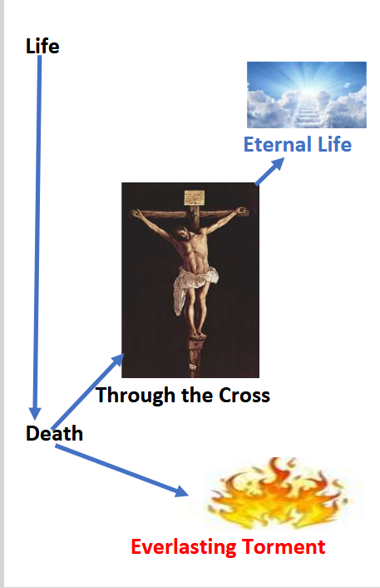
From Death To Life Through The Cross
Joe McKinney
Chapter 1
WHO BE GOD?
For this reading, you go learn about God wey dey give us life. Who be Him? Wetin He don do? E dey care for us? Wetin e wan from us? Why e bad to worship and serve any person, object, or thing wey no be God?
1. John 17:3 - "This one na eternal life: make dem sabi you, the only true God, and Jesus Christ wey you send."
a. To collect eternal life, you gatz sabi God? YES or NO
2. John 4:23, 24 - "Time don come, and e don dey happen now when true worshippers go worship the Father for spirit and truth, for na dem kind worshippers wey the Father dey find. God na spirit, and him worshippers gatz worship for spirit and truth."
a. God na spirit or matter? _________________
b. E dey find people to worship am? YES or NO
3. Acts 17:24-31 - "The God wey create the world and everything inside na the Lord of heaven and earth, and e no dey live for temples wey human dey build. E no need human hand to serve am, like say e wan anything, because na Him dey give all men life and breath and everything else. From one man, He create all nations of men, make dem dey live for the whole earth; and e don set the time wey dem go dey live and the exact places wey dem suppose stay. God do this make men go seek am and fit reach out for am and find am, even though e no far from any one of us. 'For na inside am we dey live and move and get our being.' As some of una poets don talk, 'We be Him children.'
"So since we be God's children, we no suppose think say divine being go be like gold or silver or stone-wey man design and skill make. For past, God no mind that ignorance, but now e dey tell everybody everywhere make dem repent. For e don set day wey e go judge the world with justice by the man wey e don choose. E don give proof of this to everybody."

