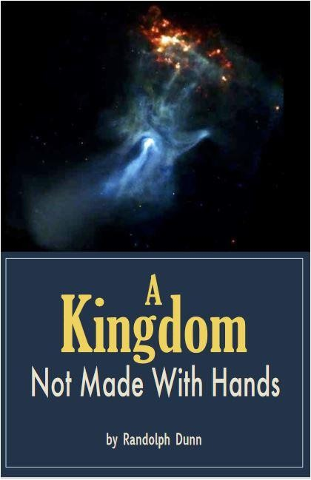
Kingdom Wey No be Hand Work
Introduction
Man wey God create na eternal and good person, e look like God but no be exact copy. “God don put eternity for man heart; but dem no sabi wetin God don do from start to finish.” (Eccl 3:13) God prepare Paradise for dem, tell dem make dem keep Eden, make dem dey fruitful and multiply, but no go chop from tree wey get the knowledge of good and evil, because if dem chop, dem go die. Dem no sabi how long dem stay there, but later dem chop from the tree, so God just carry dem comot from Eden. People believe say na this time time begin as Adam and Eve no fit chop from Tree of Life again and live forever.
Years later, God tell Abraham wey dey righteous make e go one place wey God prepare for am and hin pikin dem, one of dem go bless the whole world. E take over 400 years before Abraham pikin dem, the Israelites, reach the land wey God don promise Abraham. While dem dey there, dem dey find redeemer wey go fit forgive sin if dem obey.
By the Holy Spirit action, God come live for earth as human, to be only sin offering and “to prepare a place for you? And if I go and prepare a place for you, I will come again and will take you to myself, that where I am you may be also.” (John 14:3)
After Jesus die for cross and hin rise again, He return to Heaven and on Pentecost Day “pour(ed) out my Spirit on all people … everyone who calls on the name of the Lord will be saved” (Acts 2:17, 21) no be only Jews. Christ apostles come dey preach Good News - forgiveness of sin and salvation don open for everybody wey trust and obey Christ by dying to sin and being buried into His blood, water baptism. God go raise these obedient forgiven people from hin burial, put dem for kingdom wey no be hand work. You gatz study God word for your salvation, no be to “depend” on wetin others talk;

