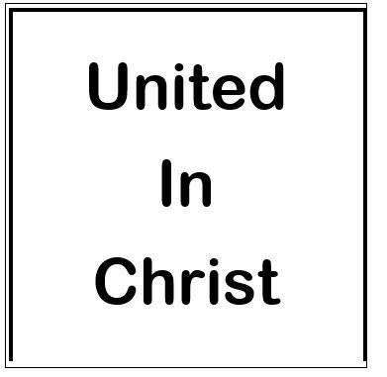

United In Christ
Randolph Dunn
Lesson 1
Jesus – The Person
The place wey Jesus born na closed society, people wey dey feel say dem sabi pass everybody. Dem dey proud as Children of Abraham, God’s chosen people. ‘Abraham na our papa’ (John 8:38). Dem get plenty hate for Samaritans because dem dey see dem as half-caste, Jews wey don forget Moses law during Babylon captivity. Their hate strong well well, dem no go even step foot for Samaritan land. Roman soldiers no different; any Jew wey dey chill with those ‘occupiers’ dey called sinner; like Matthew wey be tax collector.
The Jews dey follow law too much. Dem believe say to collect God’s promises, dem must fulfill the law letter by letter, not the spirit. For example, Moses tell dem say make dem dey pay tithe and give ten percent. To ensure dem no give pass ten percent, dem dey count seed of plants to give just ten percent.
Rome dey force the Jews to carry soldier load for one mile. So dem go mark ground to make sure say dem no go past am. Remember say Jesus talk say if person force you go one mile, follow am two (Matthew 5:41).
Na this culture the Anointed One, the Messiah, the Christ enter. Jews believe say when the Messiah come, e go bring back Israel kingdom to dem 'God-given right' to power and honor. Their Messiah go be King of the Jews and go rule like David.
Jesus dey often talk to the arrogant, self-centered Pharisees, wey be the religious leaders of the Jews. One time, Jesus talk say Him get sheep for other places. So e look like say Jesus dey refer to the Gentiles, all non-Jews.
For John 10, Jesus talk say “I be the good shepherd; I sabi my sheep [those wey choose to follow am] and my sheep sabi me [get close relationship with Him] — just a

