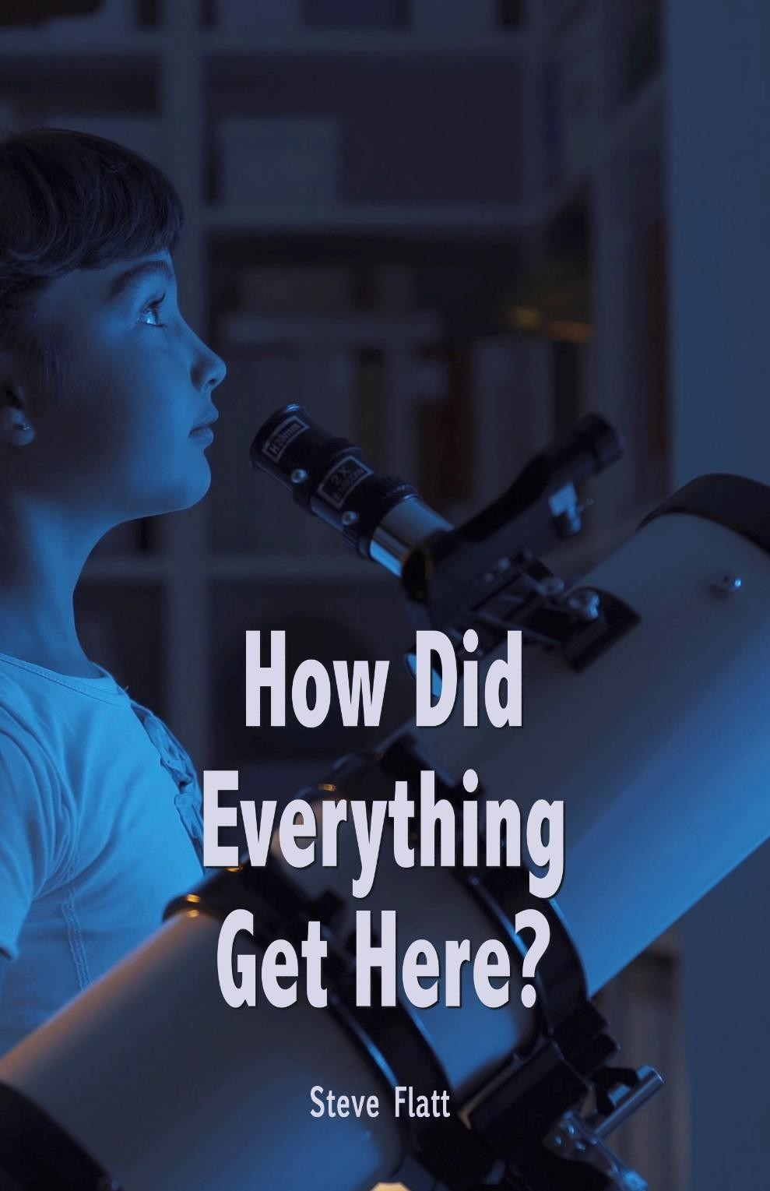

how do evritin get here?
Steve Flatt
creation or a big bang?
how do evritin begin? wia do evritin com from? di first tins a human being becomes aware for are tins dey am, di external world. Wen a baby comes into dis world, im or im na plenti aware for pipo and tins than im na wey concern imsef. It's plenti for an awareness for di externals than for di internals. As taim go on top, dem begin to realize dat dem get kweshion wey concern wia all dis tins com from. A relatively young pikin might begin dey ask kweshion wey concern we you from and dos kweshion are shikena at first. A pikin fit tok, "where do di stars for di sky com from?" a shikena kweshion usually gets a shikena ansa. If di parent na believer for god, a christian, di ansa might be, "god put dem dia. " if di parent na atheist, a non-believer, di ansa might be, "a tey tey dia na juss a huge explosion and tins juss landed for space. "

as dem grew older di kweshion become plenti sophisticated, no bi juss “how do di stars get there” or “how do di moon get there”. How do we explain galaxies wey de trillions for lait years away? how do we explain di complexity for di human bodi, di human brain, di kidney, or di eye? how do we explain all for di law and properties for physics dat hold all dis tins together? wia do all dat com from? plenti sophisticated kweshion demand plenti sophisticated and reasonable answers. We wan logically formulated answers wey go withstand questioning and probing. It's also right wey we suppose ask wey concern di we you from, and demand an ansa dat na accurate wit all sabi data and get head for di face for questioning by we and by critics. It na insult to awa intelligence to accept an ansa dat na untrue or dat na poorly formulated.

we begin to see say di source for evritin dat na, na source dat's supernatural, a source dat na for supreme power and intellect and a source dat get one morality and an ethic. By definition dat source na named god. Here's wetin paul say for romans 1:20, "for tey tey di creation for di world, god's invisible qualities, im eternal power and divine nature don been clearly seen, being understood from wetin don been make make men are without excuse. " paul na right. If you no fit look dey and sight wetin don been make and realize say di tremendous how much for evidence dia for dat supernatural, all-powerful, all-intelligent, all-moral god, wetin fit possibly prove it to you?

wia do evritin com from? evritin com from di almighty god for heaven and earth, who loved we and created we and evritin we sight.

natural law or supernatural force?
wen ask di kweshion wey concern di we you from, di christian's insight na dat dis world gats get supernatural beginning. Di very beginning for di bible, god's word, says "in di beginning, god created di heavens and di earth. " (genesis 1) dat same tin na verified ova and ova again for di scripture. "he wraps imsef for lait as wit a garment, im stretches komot di heavens laik a tent and lays di beams for im upper chambers on top dia waters. Im de make di clouds im chariot and im rides for di wings for di wind. Im de make winds im messengers, flames for faya im servants. Im set di earth on top na foundation. " (psalm 104) who created evritin e get? god do - god di papa, pikin and holy spirit.

also, colossians 1:16, states "for by am all tins de created, tins for heaven and on top earth, visible and invisible, weda thrones or powers or rulers or authorities, all tins de created by am and for am. Im na before all tins and for am, all tins hold together. " dos are di answers for di christian. How do evritin get here? dia na a supernatural force.

but for dos who would hold go di premise dat evritin com wey concern through natural forces, dem find themselves for a position wey sabi no defense.

dem get two basic tins for dis universe. E get mata and e get energy. Di wahala na dat neither mata abi energy don for and for themselves any creative force. Mata does no bi create oda mata. A piece for wood does no bi naturally create anoda piece for wood. Mata and energy are continually being bin use up. How many times you don heard scientists tell we dat dis universe for ours na running down? we are told dat awa sun, which na star for di milky way galaxy, na wey concern middle age. Supposedly, a billion years from now awa sun go eventually use all na energy. It's winding down. If awa universe na composed for mata and energy, wia do dos tins com from? by natural law, dem do no bi create themselves. Wia do dem com from? by natural law, dem be winding down and are going be spent up. Who created di great storehouse for energy for di first place? natural science knows no ansa.

di current scientific theory holds dat lait, whenever na im created, com from non-living mata. Dat's an interesting assumption, abi for a book published no bi dat long tey dem dey call “issues and evolution”, it states dat very tin, "the assumption say all life comes from nonliving mata must be make by di modern scientist if im believe say di kweshion, 'what na life?' belongs for di natural sciences. " di point na dos who propose dat dia na no supernatural cause must propose dat life com from sontin no bi alive. But, dat flies for di face for modern science. You don ever heard for di theory for spontaneous generation, a theory dat na reign for di 19th century dat life do las las com from non-living mata? di ancients bin use to believe say worms de tin be say com from horse hairs dat de put for water. Ah, but along com a noted scientist by di name for louis pasteur. You fit don heard for am, im na big for milk. Pasteur through a number for experiments verified di kpatakpata dat life no fit com from nonliving mata. Do you sight di point? do you see say dos who tok dat dis world and dis universe e get as e be juss don always been?

science don to repudiate itself to hold a non-creationist see. As we look for dis kweshion, "where do evritin com from?" wen reduced go choice, either dia na a supernatural creative force, or dia na juss natural law. Dia's realli no choice be make. Dia had be a supernatural force.

na it here by design or na it here by accident?
dey consider di fact dat awa world na filled wit millions for living tins, any one for wey be plenti complex and sophisticated than any man-made object. For oda words, dia must don been a great deal for intelligence associated wit dat supernatural force dat put evritin here. Awa bodi na composed for literally hundreds for millions for cells. Do you know say each tiny cell don an electrical system dat's plenti complex than di telephone system for a city for 30,000 pipo? isn't dat amazing? di kweshion na, "is dia any man-made object wey we would account for apart from intelligent design and production?" imagine di telephone system for a city di size for para para york city. Tink wey concern all di switches, all di intricate wiring, di satellite up-link. Tink wey concern all dat went into dat. Imagine pesin dey tell you dat send designed dat. Send drew any pictures, dia weren't any plans, and send manufactured dat entire scenario, but it juss simply happun. Di biggest mugu for di world wouldn't believe say. Basic rationality says dat if we sight sontin dat complex, we assume design and intelligence. Tey tey it na ridiculous to tink dat any man-made device na make without design and production, how boku plenti ludicrous na it to assume dat dia na no design for dis non-man-made objects, any one for wey be plenti complex? di human brain, di human bodi, di kidney - di greatest filtering system for di world. One scientist set forth for a recent journal say di chance for one protein molecule falling together for place for random - di chance for dat na 1 x 2. 02 x 10 raised go di 239th power. Na it by chance or na it design? di believer accepts passages laik psalm 19:1 wen david wrote, "the heavens are declaring di glory for god and di firmament proclaims im handiwork. " dia na las las a design and na im magnificent.

supernatural or natural?
na im supernatural. Design or accident? it gats don been design. But wetin wey concern di nature for dat creator? i'm finding plenti and plenti pipo for awa world are willing to accept di fact dat dia had be a creator, but plenti and plenti are also assuming dat creator na some cosmic force, some huge glob for energy komot dia for di universe, no bi a personal god. To wey we need to take a look for awa universe. Sometimes we sight exceptions to it, but di human creatures who inhabit dis world don an innate sense for morality. Na so? amazing dat as you span di civilizations dat inhabited dis world ova di centuries dat dia na remarkable consistency de kain we dey define gud and wetin we dey define bad. If you go back go di egyptians or di american indians or go di incas or di babylonians, civilizations dat had no contact wit each oda, and by and large dia statutory code na remarkably resemble. Na im always mago mago to murder, na im always mago mago to fap, and na im always mago mago to lai. Dia de sexual norms for each for dos civilizations. Dia na, e be laik, for inside di hearts for dos pipo an innate sense for right and wrong. Resemble across di world. Why na it wey we universally call a man laik hitler or saddam hussein evil? wetin would evil mean if we bin de no bi created by a moral creator? evil would juss be mai preference as opposed to yours, and awa preferences would be as numerous as dem get pipo for di face for dis earth, but dat's no bi di case.
we are give a sense for morality. Moral sense does no bi com from a non-moral source. If we've com from rock, dirt, and mata, wia do we get conscience or morality?

we begin to see say di source for evritin dat na, na source dat's supernatural, a source dat na for supreme power and intellect, and a source dat get one morality and an ethic, and by definition, dat source na named god. Here's wetin paul say for romans 1:20, "for tey tey di creation for di world, god's invisible qualities, im eternal power and divine nature don been clearly seen, being understood from wetin don been make make men are without excuse. " paul na right. If you no fit look dey and sight wetin don been make and realize di tremendous how much for evidence dia for dat supernatural, all-powerful, all-intelligent, all-moral god, wetin fit possibly prove it to you?
wia do evritin com from? from di almighty god for heaven and earth, who loved we and created we and evritin we sight.
amazing grace lesson # 1001 steve flatt
kweshion
1. Can eternal power and divine nature be clearly understood by wetin god don make? yes ___ no ___

2. How de tins created?
a. ___ unknown
b. ___ a big bang
c. ___ created by and eternal power
d. ___ none for di above

3. Which for di two tins for di universe de created?
a. ___ mata
b. ___ energy
c. ___ neither
4. Creation na by accident.
true ___ lie-lie ___
5. Since survival for di fittest exists for di animal world, then e get no inherent morality for humanity?
true ___ lie-lie ___

