The Good, The Bad, The Perfect

Kuwa wanaagsan, kuwa xun, the Fiican

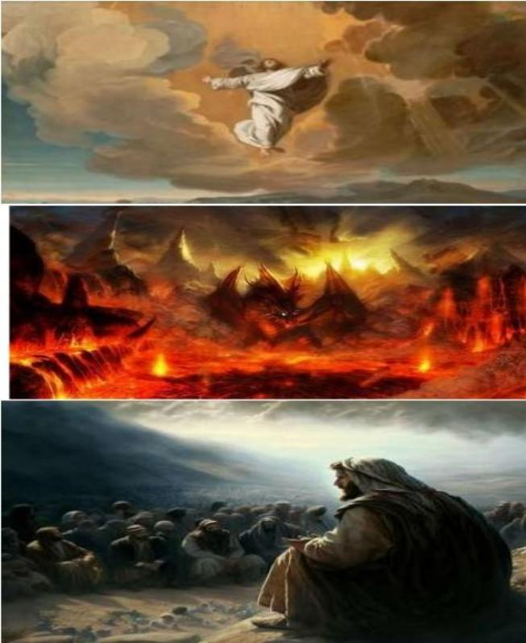

Roberto Santiago
The Good - God's Creation and His Plan

Roberto Santiago Wanaagga - abuurista Eebbe iyo qorshihiisa

In the beginning, there was only God. He existed before time, before space, before everything
we know. From His divine creativity, He created the universe and everything within it. Genesis
1:31 says, "God saw all that he had made, and it was good.” This declaration encompasses the
goodness of God's creation. From the magnificence of the galaxies to the intricacy of every living being, God's handiwork was perfect, harmonious, and beautiful.
God's goodness is further revealed in His loving intention for humanity. He created Adam and
Eve in His image of love, mercy, peace, just, faithfulness and ability to reason and decide. He placed them in the Garden of Eden, where they enjoyed a perfect
relationship with Him. Genesis 1:27 affirms this: "So God created mankind in his own image, in
the image of God he created them; male and female he created them." God's goodness was not only in His creation but also in His plan for humanity to live in harmony with Him and each other.

The Bad - The Deceiver, Accuser, and Destroyer
The story takes a tragic turn with the introduction of evil. Satan, once an angel of light, fell from grace due to pride and became the embodiment of deception and destruction. In Revelation
12:9, he is described as "that ancient serpent called the devil, or Satan, who leads the whole
world astray." Satan's mission is to accuse, deceive, and destroy God's creation. He is relentless in his attempts to lead humanity away from God and into sin.
Satan's destructive influence is evident in the disobedience of Adam and Eve. When they
succumbed to his deceit and ate from the forbidden tree, sin entered the world, and the perfect harmony of God's creation was shattered. Romans 5:12 laments this, stating, "Therefore, just as sin entered the world through one man, and death through sin, and in this way death came to all people because all sinned."

The Perfect - Jesus, the Redeemer and Restorer
In the midst of chaos and despair, God had a plan for redemption. He sent His own Son, Jesus Christ, as the perfect solution to reconcile humanity to Himself. Jesus, fully God and fully man, came into the world to destroy the works of the devil (1 John 3:8). His birth, known as

Bilowgii, waxaa jiray Ilaah keliya. Wuxuujiray ka horwaqtiga, ka hor booska, wax walba oo aan
ognahay. Laga soo bilaabo falsanaanta rabbaaniga ah, wuxuu abuuray caalamka iyo wax kasta oo ku dhex jira. Bilowgii 1:31 Wuxuu leeyahay, "Ilaah wuxuu arkay wixii uu sameeyey oo dhan, oo
way fiicneyd. Baantiinadaani oo koobaysawanaagga uunka Eebbe. Laga soo bilaabo matchence ee galaxida ee soo-galka ah ee noloshiisa kasta, gacantaIlaahay waxay ahayd mid kaamil ah,
is-is-is-is-is-is-waafajin, iyo qurux.

Wanaagnimada Eebbe ayaa sii muuqda ujeedkiisa naxariistiisa ee aadanaha. Wuxuu abuurayAadan iyo
Xaawa muuqaalka jacaylkiisajacaylka,naxariis, nabada, kaliya, aaminnimada iyo awooda sababitaanka iyo go'aansashada. Oo wuxuu ku dhigay beertii Ceeden, oo halkaas oo ay ku raaxeysteen kaamil ah
Xiriirka lala yeeshay isaga. BILOWGII 1:27 Haddaba Ilaah wuxuu ku abuuray binu-aadmiga isagoo
araggiisa ku xidhay, oo wuxuu abuuray xagga Ilaah iyo dhaddig oo kale. Wanaagsanaanta Eebbe kaliya maahan abuurkiisa laakiin sidoo kale wuxuu kujiray qorshihiisa aadanaha inuu ku noolaado qof la mid ah isagaiyo midba midka kale.

Kuwa xun - khiyaanada, eedaynta, iyo baabi'inta
Sheekadu waxay la mid tahay soo-jeedinta naxdinta leh iyadoo la soo saaray beddalka. Shayddaanku
waa mar alla markiilaata malaa'igtaiftiinka, nimco ha u ahaato, oo waxay noqotay nimco oo waxay
noqotay mid madax u ah khiyaanada iyo burburka. Muujintii 12: 9, waxaa lagutilmaamay "abeesadii
hore ee abeeso u yeedhay Ibliiska, ama Shayddaan, oo dunida oo dhan hoggaamiyo." Himilada
Shaydaanku waa inuu ku eedeeyo, khiyaaneeyo, oo uu baabi'iyo abuurista Ilaah. Isagu waa ka nabdoon isku daygiisii inuu ku hoggaamiyo aadanaha ee Ilaah iyo dembiga.

SaamayntaShaydaanka ee Shaydaanku wuxuu ku caddeeyay caasinimadaAadan iyo
Xaawo. Markay khiyaanadiisii ku koreen, oo waxay ka cuntay geedkaas oo dembigalaga
reebay, Dembigu dunidana wuu soo galiyay, oo kii ka qummanyahay abuuridda Eebbe ayaa burburay. Rooma 5:15 Sidaas daraaddeed waxaas oo sheegaya, waayo, sidaas
daraaddeed, dembigu waa nin keliya, oo uu ku dilo dembiga, oo sidan oo kale dhimashaduu u yimid, maxaa yeelay, dhammaantood way dembaabaan.

Kan kaamil ah - Ciise, dib u Bixiyaha iyo Soo Noqoshada
In fowdo iyo rajo xumo, Eebbe wuxuu lahaa qorshe loogutalagalay madax furasho. Wuxuu u soo
diray wiilkiisa, Ciise Masiix, sida xalka ugufiican ee lagu heshiisiiyo aadanaha naftiisa. Ciise, oo si
buuxda Ilaaha ah oo buuxa, ayaa dunida u yimid inuu baabi'iyo shuqullada Ibliiska (1 Yooxanaa 3: 8). Dhalashadiisa, oo loo yaqaan

Emmanuel, signaled God's presence among us, bringing hope of restoration to a fallen world.
Jesus' perfect life, sacrificial death on the cross, and triumphant resurrection offer salvation and restoration to all who believe in Him

and followed His command to be baptized. Baptism is the calling on God for forgiveness by one having died to their old sinful life. It is a burial by immersion in the Christ’s atoning sacrifice blood. Like Jesus
was resurrected, God resurrects the one pleading for forgiveness from the waters of baptism to
become a new creation in Christ Kingdom. (Romans 6:4). Through faith in Christ, we are made
perfect in God's sight, not by our own merit. Still, by His grace (Hebrews 10:14). Jesus came to undo the consequences of sin, offering eternal life. and a new beginning to those who embrace Him
becoming His servant in His Kingdom.

The concept of restoration is beautifully depicted in Revelation 21:5, "He who was seated on the throne said, 'I am making everything new!'" God's plan has always been to redeem His creation
and restore it to perfection. Those who accept Jesus as their Savior will dwell with Him in a new heaven and a new earth, where there will be no more pain, suffering, or sin (Revelation 21:1-4). The story of God's creation, the fall into sin, and the redemption through Jesus is a powerful
narrative of God's goodness, the devastating impact of evil, and the perfect work of salvation. As believers, we are called to be "perfect as your heavenly Father is perfect" (Matthew 5:48) and to live according to God's original design, restored through faith in Christ. It is through Jesus that we find hope for forgiveness, and the promise of a new world where God's goodness will once again reign supreme.

Emmanuel, wuxuu muujiyeyjiritaanka Ilaah dhexdooda, taas oo ah rajada dib u soo celinta adduunka dhacay. Ciise noloshiisa ku habboon, dhimashada allabari ee iskutallaabta dusheeda, iyo
sarakicidda guushuhu waxay bixiyaan badbaadada iyo dib u soo celinta dhammaan kuwa isaga rumeysan

Oo amarkiisana waa in la baabtiiso. Baabtiisku waa u yeedha Ilaaha cafiska mid ka mid ah markii uu u dhinto cimrigiisii hore. Waa duugista by ku aaska in laga dhex baxo ee ku saabsan allabari abbaareyntadhiig. Sida Ciise dib loo soo nooleeyay, Ilaah wuxuu u soo celiyaa mid ka mid ah
cafiska baabba'ay biyaha baabtiiska si uu u noqdo abuur cusub oo ku jira boqortooyada Masiix. (Rooma 6: 4). Iimaanka xagga Masiix, annaga waxaa lagugu qummanaa Ilaah hortiisa, oo
aannan mudnaanteena ahayn. Weli, nimcadiisa (Cibraaniyada 10:14). Ciise wuxuu u yimid inuu soo maleeyocawaaqibka dembiga, inuu bixiyo bixinta nolosha weligeed ah. Iyo bilowgii cusub kuwii isaga u yeel inuu boqornimadiisa ku noqdo boqortooyadiisii.

Fikradda dib-u-soo-celinta ayaa si qurux badan loo muujiyey Muujintii 21: 5, "Kii
carshiga ku fadhiyey wuxuu yidhi, Wax kasta oo cusub ayaan sameeyaa wax walba!
Kuwa aqbala Ciise oo ah Badbaadiyehoodu wuxuu la joogi doonaa samo cusub iyo dhul cusub, oo aan xanuun dambe lahayn, ama dembi, ama wax la soo muujiyo, 1-4).
Sheekada abuurka Eebbe, ayaa ku dhacday dembiga, oo madax furashadii Ciisena waa sheeko xoog lehwanaagga Ilaah,saameynta ba'an ee sharka, iyo shaqada qumman ee badbaadada. Sida kuwa rumaysta, waxaa nalooguyeedhay "kaamil ah sida
aabihiinnada jannada jannada ku habboon" (Matayos 5:48) iyo in ay ku noolaadaan
sida uu u yahaynaqshada Ilaah ee asalka ah, oo lagu soo celiyay rumaysadka Masiixa. Waa Ciise oo aan helno rajocafis, iyo yabooh dunida cusub oo wanaagga Eebbe uu
mar kale xukumi doono.

