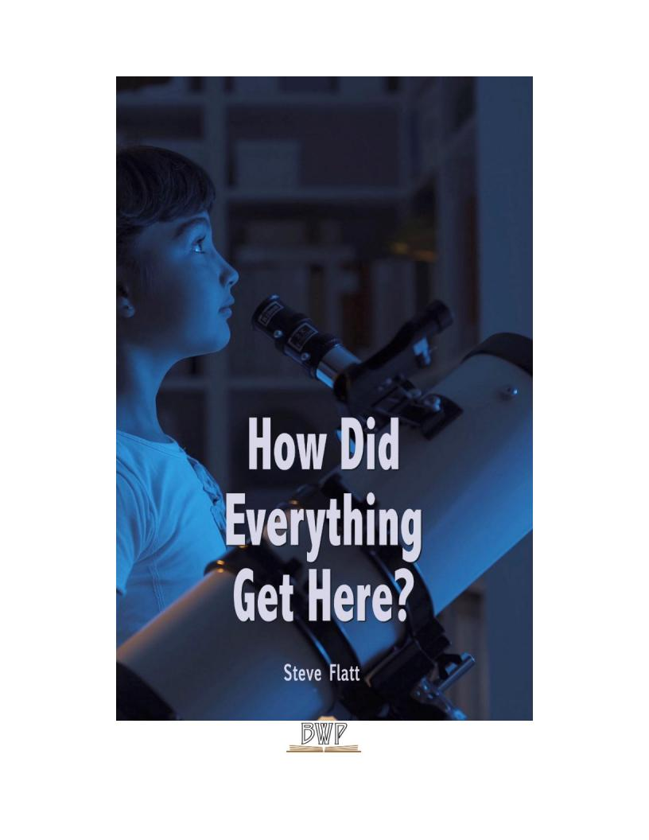

Konke kwenzeka kanjani lapha?

Indalo noma i-bang enkulu?
Konke kwenzeka kanjani? Konke kwavelaphi? Izinto zokuqala umuntu azibonayo
ziyizinto eziseduze kwakhe, izwe langaphandle. Lapho ingane iza kulomhlaba, iyabazi kakhulu abantu nezinto ezingaphezukwayo ngayo. Kungokuqwashisa kwangaphandle kwangaphandle kunabantu abangaphandle. Njengoba isikhathi siqhubeka,baqala
ukubona ukuthi kunemibuzo ngokuthi zonke lezi zinto zivelaphi. Ingane encane ingaqala ukubuza imibuzo ngemvelaphi futhi leyo mibuzo ilula ekuqaleni. Ingane ingathi, "Izinkanyezi esibhakabhakeni zazivelaphi?" Umbuzo olula uvame ukuthola impendulo elula. Uma umzali ekholwa nguNkulunkulu, umKristu, impendulo
kungenzeka ukuthi, "uNkulunkuluwababeka lapho." Uma umzali engakholelwa ukuthi uNkulunkulu ukhona, okholwa ongeyena okholwa, impenduloingabayikho, "kudala lapho kwakukhona njeukuqhuma okukhulu nezinto ezisanda kufakwa esikhaleni."

Njengoba bekhula le mibuzo ibayinkimbinkimbingokwengeziwe,hhayinje "izinkanyezi zafika kanjani lapho" noma "inyangayafika kanjani lapho". Simchazela kanjani imithala eyizigidigidizeminyakayokukhanya? Sikuchaza kanjani ubunzima bomzimba womuntu, ubuchophobomuntu, izinso noma iso? Siyichaza kanjani yonke imithetho nezakhiwo
ze-physics ebambe zonke lezi zinto ndawonye? Konke kwavelaphi? Imibuzo
eyinkimbinkimbingokwengeziwe ifuna izimpenduloeziyinkimbinkimbi futhi
ezinengqondo. Sifuna izimpendulo ezenziwe ngokunengqondo ezizomelana nemibuzo nokuphenya. Kulungile futhi ukuthi kufanele sibuze ngemvelaphi, futhi sifuna
impenduloeqondile ngayoyonkeimininingwaneeyaziwayo futhi enengqondo
ebusweni bokubuzwayi-US nakwabagxeki. Kuyinhlamba ebuhlakani bethu ukwamukela impendulookungelona iqiniso noma lokho kumiswe kabi.

Siqala ukubona ukuthi umthombo wayo konke okuwukuwukukhona, umthombo
ongaphezulu kwemvelo, umthombo ongamandla amakhulu nangobuhlakani nomthombo
onokuziphatha kanye nokuziphatha okuhle. Ngencazelo leyo mthombo iqanjwe
uNkulunkulu. Nakhu okushiwo uPawulu kwabaseRoma 1:20, "ngoba kusukela ekudalweni komhlaba, izimfanelo zikaNkulunkulu ezingabonakali, amandla akhe aphakade kanye
nemvelo yaphezulu ziye zabonakala kahle, kuqondwe ngokwenziwe kwalezabalisa."
UPawulu wayeqinisile. Uma ungakwazi ukubheka nxazonke futhi ubone okwenziwe futhi uqaphele ukuthi ubufakazi obukhulu obukhona lapho ngenxayalolo lwasesimweni
esinamandla, esinamandla, sonke esihlakaniphile, uNkulunkulu ongakufakazela kuwe?

Konke kwavelaphi? Konke kwaqhamuka kuNkulunkulu uSomandla wezulu nomhlaba, owasithanda futhi wasidalela nathi konke esikubonayo.

Umthethowemvelo noma amandla angaphezu kwawemvelo?
Lapho ebuzwa umbuzo ngemvelaphi, ukuqonda komKristu ukuthi lo mhlaba bekufanele ube nesiqaloesingaphezu kwawemvelo. Ukuqala kokuqalakweBhayibheli, iZwi
likaNkulunkulu, lithi ekuqaleni, uNkulunkuluwadala amazulu nomhlaba. " (UGenesisi 1)
Leyo nto efanayo iqinisekiswakaningi embhalweni. "Uzihlanza ngokukhanya
njengokugqoka kwengubo, welula amazulu njengetende, wenza amafu amakamelo akhe angenhla emaphepheniaphezulu. Wenza izithunywa zayo, amalangabi omlilo
wakhe." Wabeka umhlaba esisekelweni sawo. " (IHu. 104) Ngubani owadala konke
okukhona? UNkulunkuluwakwenza - uNkulunkulu uYise, indodana nomoya ongcwele.

Futhi, KwabaseKolose 1:16, 'ngoba zonke izinto zadalwa, izinto ezulwini nasemhlabeni,
zibonakale futhi zingabonakali, noma izikhulu, zonke izinto zadalwa kuye kuye, zonke izinto zibambe. " Lezo yizimpendulo zomKristu. Konke kwenzeka kanjani lapha? Kwakukhona
amandla angaphezu kwawemvelo.

Kepha kulabo ababebambelela esibonelweni sokuthi konke kwavela ngamabuthoemvelo, bazithola sesimweni esingasazi.

Kunezinto ezimbili eziyisisekelo kule ndawo yonke. Kunendaba futhi kukhona amandla. Inkinga ukuthi noma ngabe akunandaba noma amandla nawo anawo noma yimaphi amandla okudala. Indaba ayidali enye into. Ucezu lokhuni aludali ngokwemvelo olunye ukhuni. Into namandla asetshenziswa njalo. Kukangaki uzwe ososayensi basitshela
ukuthi le ndawo yakithi yehla? Sitshelwa ukuthi ilangalethu, okuyinkanyezi eMilky Way Galaxy,imayelana nobudala obuphakathi. Kucatshangelwe, iminyaka eyizigidi
eziyinkulungwane kusuka manje ilanga lethu lizogcina lisebenzise wonke amandla alo. Kumiswa phansi. Uma umkhathi wethu wakhiwa ngendabanemandla, kwavelaphi
izinto? Ngomthethowemvelo,abazenzelanga. Bavelaphi? Ngomthethowezemvelo, bahlehla phansi futhi bazosetshenziswa. Ngubani owadala isitolo esikhulu samandla endaweniyokuqala? Isayensiyemvelo ayazi.

Umbonowamanjewesayensi ubamba lokho kuKhanya, noma nini laphokwadalwa, kwaqhamuka ezintweni ezingaphili. Lokho umcabango othokozisayo,akunjalo? Encwadini eshicilelwe kungekudala ibizwa ngokuthi "izingqinamba kanye nokuziphendukelakwemvelo", ithi le nto, "umcabango wokuthi konke impilo kuvela ngaphandle

Into ephilayo kumeleyenziwe ngusosayensiwanamuhla uma ikholelwa lowo mbuzo, 'Iyini impilo?'kungokwesayensiyemvelo. "Iphuzu yilaboabaphakamisa ukuthi alikho yiniimbangela yangaphezu kwemvelo okuvela endabeniyezesayensi yanamuhla,
wake wakuzwakala ngokuphilakwesayensi yanamuhla. Ah, kodwa wafika ososayensi abaphawuliwe ngu Igama likaLouis Pasteur. Kungenzeka ukuthi uke wezwa ngaye,
waba mkhulu obisini. Pheqangokuhlola okuthile okuqinisekiswa kwesiphetho sokuthi impilo ayinakuvelayini kulomhlaba futhi le ndawo yonke bekulokhu kunjalo?

Isayensi kufanele ilahle ukuze ibambe umbono ongaphenduli. Njengoba sibheka lo mbuzo,
"Konke kwavelaphi?" Lapho incishiswa iyeekukhetheni, kungaba khona okungaphezu kwemvelo
amandla okudala, noma kwakukhona umthethowemvelo. Akunakho ukukhetha okufanele kwenziwe. Kwakufanele kube khona amandla angaphezu kwawemvelo.

Ingabe laphayi-Design noma ingabe laphangengozi?
Cabangangeqiniso lokuthi umhlabawethu ugcweleizigidi zezinto eziphilayo, noma yimuphi
wazo owunkimbinkimbi kakhulu futhi ucindezelekile kunanoma iyiphi into eyenziwe ngumuntu. Ngamanye amagama, kufanele ngabe bekukhona ubuhlakani obukhulu obuhambisana nalewo mandla angaphezu kwawemvelo abeka konke lapha. Umzimba wethu wakhiwa ngamakhulu
ezigidi zamaseli. Ubuwazi ukuthi iseli elincane ngalinye linohlelo lukagesioluyinkimbinkimbi ukwedlula uhlelo lwezingcingo lwedolobha labantu abangama-30,000? Akumangazi lokho?
Umbuzo uwukuthi, "Ingabe kukhona into eyenziwe ngumuntu ukuthi sizoba ne-account for
ngaphandle komklamo ohlakaniphilenokukhiqizwa?" Cabangangohlelo lwefoni edolobheni
usayizi weNew York City. Cabanga ngawowonke ama-switch, lonke i-wiring eyinkimbinkimbi, isixhumanisi se-satellite up-isixhumanisi. Cabangangakho konke okungena kulokho. Cabanga othile okutshela ukuthi akekho umuntu owaklama lokho. Akekho odonsile noma yiziphi
izithombe, kwakungezona amapulani, futhi akekho owenze leso simo, kodwa kumane
kwenzeka nje. Isiwula esikhulu kunazo zonke emhlabeni ngeke sikukholwe lokho. I-rationality eyisisekelo ithi uma sibona okuthile okuyinkimbinkimbi, sikuthatha ukuklama nobuhlakani.
Njengoba kumnandi ukucabanga ukuthi noma iyiphiidivaysieyenziwe ngumuntu yenziwe
ngaphandle kokwakheka nokukhiqizwa, kangangani kangakanani i-ludicrous ukucatshangelwa ukuthi ayikho into eyakhiwengalezi zinto ezingenziwanga?Ubuchophobomuntu, umzimba
womuntu, izinso - uhlelo olukhulu kakhulu lokuhlunga emhlabeni. Ososayensi abathile babeka ejelelo yakamuvayokuthi ithuba le-molecule elilodwa lamaprotheni liwa ndawonye endaweni engahleliwe - ithuba layolalingu-1 x 2.02 x 10 akhuphuke emandleni angama-239. Ingabe
ngengozi noma ingabe iklanywe? Ikholwa liyamukela izindima ezinjengemaHubo 19: 1 Lapho uDavide ebhala, "amazulu amemezela inkazimulo kaNkulunkulu futhi ifemumenti limemezela umsebenziwalowezandla." Kwakunombono ngempela futhi kwakumnandi.

Ngaphezulu kwemvelo noma yemvelo?
Kwakungaphezu kwemvelo. Design noma ingozi? Kwakufanele ngabe kwakhiwe. Kepha
kuthiwani ngohlobo lwalowo mdali? Ngithola abantu abaningingokwengeziwe emhlabeni wethu bazimisele ukwamukela iqiniso lokuthi kwakufanele kube khona uMdali, kodwa futhi futhi bacabanga ukuthi uMdaliwawungamandla athile akhona,hhayi uNkulunkulu
onamandla. Kulokho kudingeka sibheke umkhathi wethu. Kwesinye isikhathi sibona
okuhlukile kuyo, kepha izidalwa ezimuntu ezikhona emhlabeni zinomqondowangaphakathi wokuziphatha. Akumangazi yini ukuthi njengoba udlula impucukoeyayihlale kulomhlaba
emakhulwini eminyakalaphokunokunye ukuguquguqukaokumangalisayo kwalokho
esikushoyo okuhle nalokho esikubiza njengokubi. Uma ubuyela kwabaseGibhithe noma amaNdiya aseMelika noma ama-Inca noma eBabiloni, izimpucuko ezazingenakuxhumana nomunye, futhi ikhodiyazo emthethweniyafanangokumangazayo. Kwakuhlala
kungenamthetho ukubulawa kwabantu, bekuhlala kungenamthethoukuntshontsha, futhi
bekuhlale kungokomthethoukuqamba amanga. Kwakukhona izinkambiso zobulili kulolo
nalunye lempucuko. Kwakunjalo, kubonakala sengathi,ngaphakathikwezinhliziyo zalabo
bantu umuzwa wangaphakathiwokulungilenokungalungile. Okufanayo emhlabenijikelele. Kungani kungukuthi uphindwengumhlaba wonke njengoHitler noma uSaddam Hussein
okubi? Kusho ukuthini okubi ukube besingadalwanganguMdali wokuziphatha? Ububi buzoba ngumuntu othanda njengokungafaninelakho, futhi okuthandayo kungababuninginjengoba kunabantu ebusweni bomhlaba, kepha akunjalo.
Sinikezwa umuzwa wokuziphatha. Umuzwa wokuziphatha akaveli emthonjeni ongewona isimilo. Uma siqhamukaedwaleni,ukungcola, kanye nathi, saluthola kuphi unembeza noma isimilo?

Siqala ukubona ukuthi umthombo wayo konke okuwukuwukukhona, umthombo
ongamandla angaphezu kwawemvelo, umthombo onamandla amakhulu nokuqonda,
nomthombo onokuziphatha kanye nokuziphatha okuhle, lokho kuchazwa kwathiwa
uNkulunkulu. Nakhu okushiwo uPawulu kwabaseRoma 1:20, "ngoba kusukela ekudalweni komhlaba, izimfanelo zikaNkulunkulu ezingabonakali, amandla akhe aphakade kanye
nemvelo yaphezulu ziye zabonakala kahle, kuqondwe ngokwenziwe kwalezabalisa."
UPawulu wayeqinisile. Uma ungakwazi ukubheka futhi ubone okwenziwe futhi uqaphele ubufakazi obukhulu laphongalobobufakaziobunamandla, obunamandla, bonke
uNkulunkulu obuhlakanipheko, yiniokungenzeka ukuthi bakufakazile kuwe?
Konke kwavelaphi? KuNkulunkulu uSomandla wezulu nomhlaba, owasithanda futhi wasidalela nathi konke esikubonayo.
Isifundo somusa esimangalisayo # 1001 Steve Flatt
Imibuzo
1. Ngabe amandla amade nemvelo yaphezulu kungaqondakala kahle ngalokho uNkulunkulu akwenzile? Yebo ___ cha ___

2. Zenziwa kanjani izinto? a. ___ akwaziwa

b. I-bang enkulu
c. kudalwe ngamandla naphakade
d. Akukho kulokhu okungenhla

3. Yiziphi kulezi zinto ezimbili endaweniyonke ezakhiwe?
a. Daba
b. amandla c. noma cha

4. Indalo ibisengozini.
Iqiniso Amanga
5
Ngobuntu? Iqiniso Amanga
isi kwezilimi ku-BibleAyonline.com.

