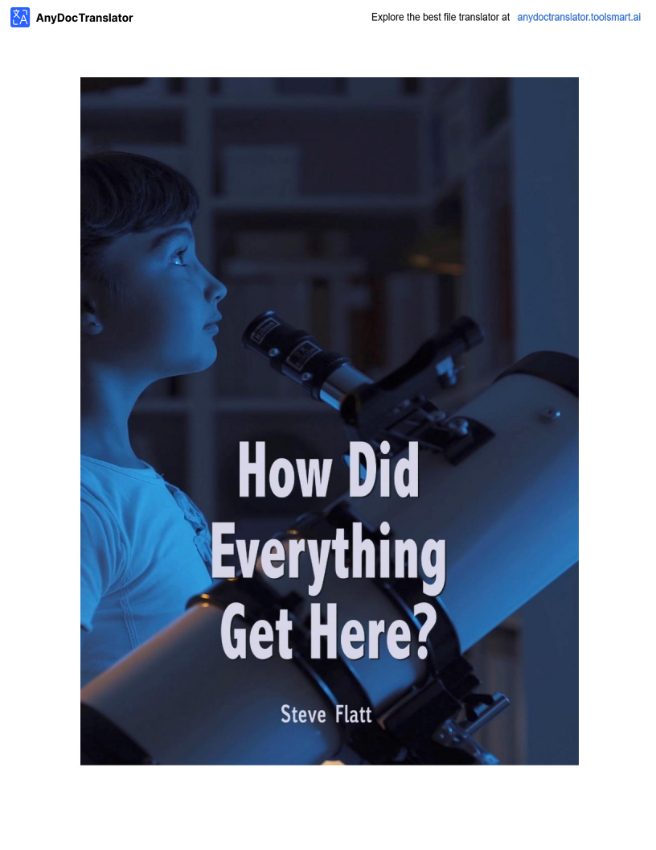

Konke kwenzeka kanjani lapha? Indalo noma i-bang enkulu?
Konke kwenzeka kanjani? Konke kwavelaphi? Izinto zokuqala umuntu azibonayo ziyizinto eziseduze kwakhe, izwe langaphandle. Lapho ingane iza kulomhlaba, iyabazi kakhulu
abantu nezinto ezingaphezukwayo ngayo. Kungokuqwashisa kwangaphandle
kwangaphandle kunabantu abangaphandle. Njengoba isikhathi siqhubeka,baqala
ukubona ukuthi kunemibuzo ngokuthi zonke lezi zinto zivelaphi. Ingane encane ingaqala ukubuza imibuzo ngemvelaphi futhi leyo mibuzo ilula ekuqaleni. Ingane ingathi,
"Izinkanyezi esibhakabhakeni zazivelaphi?" Umbuzo olula uvame ukuthola impendulo
elula. Uma umzali ekholwa nguNkulunkulu, umKristu, impendulo kungenzeka ukuthi,
"uNkulunkuluwababeka lapho." Uma umzali engakholelwa ukuthi uNkulunkulu ukhona, okholwa ongeyena okholwa, impenduloingabayikho, "kudala lapho kwakukhona nje
ukuqhuma okukhulu nezinto ezisanda kufakwa esikhaleni."

Njengoba bekhula le mibuzo ibayinkimbinkimbingokwengeziwe,hhayinje "izinkanyezi zafika kanjani lapho" noma "inyangayafika kanjani lapho". Simchazela kanjani imithala eyizigidigidizeminyakayokukhanya? Sikuchaza kanjani ubunzima bomzimba womuntu, ubuchophobomuntu, izinso noma iso? Siyichaza kanjani yonke imithetho nezakhiwo
ze-physics ebambe zonke lezi zinto ndawonye? Konke kwavelaphi? Imibuzo
eyinkimbinkimbingokwengeziwe ifuna izimpenduloeziyinkimbinkimbi futhi
ezinengqondo. Sifuna izimpendulo ezenziwe ngokunengqondo ezizomelana nemibuzo nokuphenya. Kulungile futhi ukuthi kufanele sibuze ngemvelaphi, futhi sifuna
impenduloeqondile ngayoyonkeimininingwaneeyaziwayo futhi enengqondo
ebusweni bokubuzwayi-US nakwabagxeki. Kuyinhlamba ebuhlakani bethu ukwamukela impendulookungelona iqiniso noma lokho kumiswe kabi.

Siqala ukubona ukuthi umthombo wayo konke okuwukuwukukhona, umthombo
ongaphezulu kwemvelo, umthombo ongamandla amakhulu nangobuhlakani
nomthombo onokuziphathakanye nokuziphatha okuhle. Ngencazelo leyo mthombo
iqanjwe uNkulunkulu. Nakhu okushiwo uPawulu kwabaseRoma 1:20, "ngoba kusukela ekudalweni komhlaba, izimfanelo zikaNkulunkulu ezingabonakali, amandla akhe
aphakade kanye nemvelo yaphezulu ziye zabonakala kahle, kuqondwe ngokwenziwe
kwalezabalisa." UPawulu wayeqinisile. Uma ungakwazi ukubheka nxazonke futhi ubone okwenziwe futhi uqaphele ukuthi ubufakazi obukhulu obukhona lapho kulolo mbono onamandla, onamandla onke, ohlakaniphe, ongakufakazela lokho?

Konke kwavelaphi? Konke kwaqhamuka kuNkulunkulu uSomandla wezulu nomhlaba, owasithanda futhi wasidalela nathi konke esikubonayo.

Umthethowemvelo noma amandla angaphezu kwawemvelo?
Lapho ebuzwa umbuzo ngemvelaphi, ukuqonda komKristu ukuthi lo mhlaba bekufanele ube nesiqaloesingaphezu kwawemvelo. Ukuqala kokuqalakweBhayibheli, iZwi
likaNkulunkulu, lithi ekuqaleni, uNkulunkuluwadala amazulu nomhlaba. " (UGenesisi 1)
Leyo nto efanayo iqinisekiswakaningi embhalweni. "Uzihlanza ngokukhanya
njengokugqoka kwengubo, welula amazulu njengetende, wenza amafu amakamelo akhe angenhla emaphepheniaphezulu. Wenza izithunywa zayo, amalangabi omlilo
wakhe." Wabeka umhlaba esisekelweni sawo. " (IHu. 104) Ngubani owadala konke
okukhona? UNkulunkuluwakwenza - uNkulunkulu uYise, indodana nomoya ongcwele.

Futhi, KwabaseKolose 1:16, 'ngoba zonke izinto zadalwa, izinto ezulwini nasemhlabeni,
zibonakale futhi zingabonakali, noma izikhulu, zonke izinto zadalwa kuye kuye, zonke izinto zibambe. " Lezo yizimpendulo zomKristu. Konke kwenzeka kanjani lapha? Kwakukhona
amandla angaphezu kwawemvelo.

Kepha kulabo ababebambelela esibonelweni sokuthi konke kwavela ngamabuthoemvelo, bazithola sesimweni esingasazi.

Kunezinto ezimbili eziyisisekelo kule ndawo yonke. Kunendaba futhi kukhona amandla. Inkinga ukuthi noma ngabe akunandaba noma amandla nawo anawo noma yimaphi amandla okudala. Indaba ayidali enye into. Ucezu lokhuni aludali ngokwemvelo olunye ukhuni. Into namandla asetshenziswa njalo. Kukangaki uzwe ososayensi basitshela
ukuthi le ndawo yakithi yehla? Sitshelwa ukuthi ilangalethu, okuyinkanyezi eMilky Way Galaxy,imayelana nobudala obuphakathi. Kucatshangelwe, iminyaka eyizigidi
eziyinkulungwane kusuka manje ilanga lethu lizogcina lisebenzise wonke amandla alo. Kumiswa phansi. Uma umkhathi wethu wakhiwa ngendabanemandla, kwavelaphi
izinto? Ngomthethowemvelo,abazenzelanga. Bavelaphi? Ngomthethowezemvelo, bahlehla phansi futhi bazosetshenziswa. Ngubani owadala isitolo esikhulu samandla endaweniyokuqala? Isayensiyemvelo ayazi.

Umbonowamanjewesayensi ubamba lokho kuKhanya, noma nini laphokwadalwa, kwaqhamuka ezintweni ezingaphili. Lokho umcabango othokozisayo,akunjalo? Encwadini eshicilelwe
kungekudala ibizwa ngokuthi "izingqinamba kanye nokuziphendukelakwemvelo", ithi le nto,
"umcabango wokuthi konke okuphilayo kuvela entweni engeyona eyenziwa uma ekholelwa lowo
mbuso, 'Yini impilo?'kungokwesayensiyemvelo. " Iphuzu yilaboabaphakamisa ukuthi
kwakungekho mandla angaphezu kwawemvelo kumele ahlongoze ukuthi impilo yaqhamuka entweni engaphili. Kepha, lokho kundiza lapho kubhekene nesayensi yanamuhla. Wake wezwa ngombonowesizukulwane esizenzakalelayo, umbono owayedumile

Ngekhulu le-19 lelo mpilo lalivelayini edabeni elingaphili?Amandulo asetshenziselwa ukukholelwa ukuthi izibunguempeleni zivela ezinweleni zamahhashi ezazincishwe
emanzini. Ah, kodwa wafika usosayensi ophawuliwe ngegama likaLouis PASTER.
Kungenzeka ukuthi uke wezwa ngaye, wayemkhulu obisini. Pasteur ngokusebenzisa inqwabayezivivinyo ziqinisekisile isiphetho sokuthi impilo ayinakuvela entweni
engaphili. Uyalibona iphuzu?Uyabona yini ukuthi labo abathi umhlaba nale ndawo yonkengandlela thile bekulokhu kunjalo?

Isayensi kufanele ilahle ukuze ibambe umbono ongaphenduli. Njengoba sibheka lo mbuzo, "kuphi
Ngabe konke kwavela? "Lapho kuncishiswa ekukhetheni, kungaba khona ubudlova abangaphezu kwemvelo amandla, noma kwakukhona nje umthethowemvelo. Akunakho ukukhetha okufanele
kwenziwe. Kwakufanele kube khona amandla angaphezu kwawemvelo.

Ingabe laphayi-Design noma ingabe laphangengozi?
Cabangangeqiniso lokuthi umhlabawethu ugcweleizigidi zezinto eziphilayo, noma yimuphi
wazo owunkimbinkimbi kakhulu futhi ucindezelekile kunanoma iyiphi into eyenziwe ngumuntu. Ngamanye amagama, kufanele ngabe bekukhona ubuhlakani obukhulu obuhambisana nalewo mandla angaphezu kwawemvelo abeka konke lapha. Umzimba wethu wakhiwa ngamakhulu
ezigidi zamaseli. Ubuwazi ukuthi iseli elincane ngalinye linohlelo lukagesioluyinkimbinkimbi ukwedlula uhlelo lwezingcingo lwedolobha labantu abangama-30,000? Akumangazi lokho?
Umbuzo uwukuthi, "Ingabe kukhona into eyenziwe ngumuntu ukuthi sizoba ne-account for
ngaphandle komklamo ohlakaniphilenokukhiqizwa?" Cabangangohlelo lwefoni edolobheni
usayizi weNew York City. Cabanga ngawowonke ama-switch, lonke i-wiring eyinkimbinkimbi, isixhumanisi se-satellite up-isixhumanisi. Cabangangakho konke okungena kulokho. Cabanga othile okutshela ukuthi akekho umuntu owaklama lokho. Akekho odonsile noma yiziphi
izithombe, kwakungezona amapulani, futhi akekho owenze leso simo, kodwa kumane
kwenzeka nje. Isiwula esikhulu kunazo zonke emhlabeni ngeke sikukholwe lokho. I-rationality eyisisekelo ithi uma sibona okuthile okuyinkimbinkimbi, sikuthatha ukuklama nobuhlakani.
Njengoba kumnandi ukucabanga ukuthi noma iyiphiidivaysieyenziwe ngumuntu yenziwe
ngaphandle kokwakheka nokukhiqizwa, kangangani kangakanani i-ludicrous ukucatshangelwa ukuthi ayikho into eyakhiwengalezi zinto ezingenziwanga?Ubuchophobomuntu, umzimba
womuntu, izinso - uhlelo olukhulu kakhulu lokuhlunga emhlabeni. Ososayensi abathile babeka ejelelo yakamuvayokuthi ithuba le-molecule elilodwa lamaprotheni liwa ndawonye endaweni engahleliwe - ithuba layolalingu-1 x 2.02 x 10 akhuphuke emandleni angama-239. Ingabe
ngengozi noma ingabe iklanywe? Ikholwa liyamukela izindima ezinjengemaHubo 19: 1 Lapho uDavide ebhala, "amazulu amemezela inkazimulo kaNkulunkulu futhi ifemumenti limemezela umsebenziwalowezandla." Kwakunombono ngempela futhi kwakumnandi.

Ngaphezulu kwemvelo noma yemvelo?
Kwakungaphezu kwemvelo. Design noma ingozi? Kwakufanele ngabe kwakhiwe. Kepha kuthiwani ngohlobo lwalowo mdali? Ngithola abantu abaningingokwengeziwe emhlabeni wethu bazimisele ukwamukela iqiniso lokuthi

Kwakufanele kube khona uMdali, kepha futhi kucatshangelwa futhi ukuthi uMdali
wayengamandla athile akwa-cosmic, elinye izwe elikhulu laphaya endaweniyonke,hhayi
uNkulunkulu uqobo. Kulokho kudingeka sibheke umkhathi wethu. Kwesinye isikhathi sibona
okuhlukile kuyo, kepha izidalwa ezimuntu ezikhona emhlabeni zinomqondowangaphakathi
wokuziphatha. Akumangazi yini ukuthi njengoba udlula impucukoeyayihlale kulomhlaba
emakhulwini eminyakalaphokunokunye ukuguquguqukaokumangalisayo kwalokho esikushoyo okuhle nalokho esikubiza njengokubi. Uma ubuyela kwabaseGibhithe noma amaNdiya aseMelika noma ama-Inca noma eBabiloni, izimpucuko ezazingenakuxhumana nomunye, futhi ikhodiyazo emthethweniyafanangokumangazayo. Kwakuhlala kungenamthetho ukubulawa kwabantu,
bekuhlala kungenamthethoukuntshontsha, futhi bekuhlale kungokomthethoukuqamba
amanga. Kwakukhona izinkambiso zobulili kulolo nalunye lempucuko. Kwakunjalo, kubonakala
sengathi,ngaphakathikwezinhliziyo zalabo bantu umuzwa wangaphakathiwokulungile
nokungalungile. Okufanayo emhlabenijikelele. Kungani kungukuthi uphindwengumhlaba wonke njengoHitler noma uSaddam Hussein okubi? Kusho ukuthini okubi ukube besingadalwanga
nguMdali wokuziphatha? Ububi buzoba ngumuntu othanda njengokungafaninelakho, futhi okuthandayo kungababuninginjengoba kunabantu ebusweni bomhlaba, kepha akunjalo.

Sinikezwa umuzwa wokuziphatha. Umuzwa wokuziphatha akaveli emthonjeni ongewona
isimilo. Uma siqhamukaedwaleni,ukungcola, kanye nathi, saluthola kuphi unembeza noma isimilo?

Siqala ukubona ukuthi umthombo wayo konke okuwukuwukukhona, umthombo ongamandla angaphezu kwawemvelo, umthombo onamandla amakhulu nokuqonda, nomthombo
onokuziphatha kanye nokuziphatha okuhle, lokho kuchazwa kwathiwa uNkulunkulu. Nakhu okushiwo uPawulu kwabaseRoma 1:20, "ngoba kusukela ekudalweni komhlaba, izimfanelo zikaNkulunkulu ezingabonakali, amandla akhe aphakade kanye nemvelo yaphezulu ziye
zabonakala kahle, kuqondwe ngokwenziwe kwalezabalisa." UPawulu wayeqinisile. Uma
ungakwazi ukubheka nxazonke futhi ubone okwenziwe futhi uqaphele ubufakazi obukhulu
obukhona lapho ngenxayalolo lolo lwasekusasa, olunamandla, olunobuhlakani obuhlakanipheko, bonke - uNkulunkulu ongakufakazela kuwe?
Konke kwavelaphi? KuNkulunkulu uSomandla wezulu nomhlaba, owasithanda futhi wasidalela nathi konke esikubonayo.
Isifundo somusa esimangalisayo # 1001 Steve Flatt
Imibuzo
1. Ngabe amandla amade nemvelo yaphezulu kungaqondakala kahle ngalokho uNkulunkulu akwenzile? Yebo
Cha
___

2. Zenziwa kanjani izinto?
a. akwaziwa
b. I-bang enkulu
c. kudalwe ngamandla naphakade

d. Akukho kulokhu okungenhla

3. Yiziphi kulezi zinto ezimbili endaweniyonke ezakhiwe?
a. Daba
b. amandla c. noma cha
4. Indalo ibisengozini. Iqiniso____ Amanga ___
5. Njengoba ukusinda kwe-fittest kukhona emhlabeni wezilwane, khona-ke akunakuziphatha
oku nNggounulo
Iqiniso Amanga

